SentinelAI
AI-Based Threat Intelligence Platform

Project Type | MOOC / Guided Project
Technology Stack | Python, Flask, SQLite, scikit-learn, HTML, CSS, JavaScript
AI/ML Components | Random Forest (URL classifier), TF-IDF + Logistic Regression (incident text classifier)
Prepared For | SmartInternz Project Submission
Prepared By | Mansi Sarjerao Gavade

Project Summary: SentinelAI is a full-stack threat intelligence platform that lets analysts track Indicators of Compromise (IOCs), visualize threat trends on a live dashboard, and use two genuinely trained machine learning models to triage suspicious URLs and free-text incident reports in real time.

Table of Contents
- Introduction and Project Overview
- Objectives and Project Scope
- Technology Stack
- System Architecture and Workflow
- Installation and Execution Steps
- Database Design
- AI / Machine Learning Models
- Application Modules with Screenshot Placeholders
- Testing and Verification
- Limitations and Future Enhancements
- Conclusion

1. Introduction
SentinelAI is a full-stack, AI-based threat intelligence platform built to help security analysts track, investigate, and triage cyber threats. The platform combines a relational threat database with two independently trained machine learning models: a Random Forest classifier that scores suspicious URLs/domains/IPs, and a TF-IDF + Logistic Regression classifier that categorizes free-text security incident descriptions into one of seven attack types.
The project is implemented as a single Flask application that serves both the backend REST API and the frontend (HTML/CSS/JavaScript) from one server on one port, removing the need for a separate frontend server or CORS configuration. Data is stored in a local SQLite database using raw SQL (no ORM), keeping every query transparent and easy to explain in a viva or demo.
The platform supports two roles — admin and analyst — with hashed passwords and server-side sessions, and is designed so that every important action (such as deleting a threat record) is enforced on the backend, not just hidden in the UI.

2. Objectives and Project Scope
- Build a centralized threat intelligence platform to record, search, and manage Indicators of Compromise (IOCs) such as IPs, domains, URLs, file hashes, and emails.
- Implement secure authentication with hashed passwords, server-side sessions, and role-based access control (admin vs analyst).
- Train and integrate a Random Forest model that classifies a URL/domain/IP as benign, suspicious, or malicious from 16 engineered lexical features.
- Train and integrate a TF-IDF + Logistic Regression model that classifies a free-text incident description into one of seven threat categories.
- Cross-check AI predictions against the existing threat database so already-known IOCs are matched directly instead of being re-scored by the model.
- Provide a live analytics dashboard with trend charts, a severity breakdown, and a recent-threats table.
- Provide a date-range filtered reporting module with one-click CSV export.
- Expose a single health-check endpoint that verifies database connectivity and confirms both AI models are trained and loaded.

3. Technology Stack
Layer | Technology Used | Purpose
Backend | Python 3, Flask | HTTP routes, sessions, business logic, REST API
AI / Machine Learning | scikit-learn (RandomForestClassifier, TF-IDF, LogisticRegression) | URL risk scoring and incident text classification
Database | SQLite (raw sqlite3 module, no ORM) | Stores users, threats, and AI analysis logs
Frontend | Vanilla HTML, CSS, JavaScript (no framework) | Login, dashboard, threats, analyzer, and reports pages
Charts | Chart.js (CDN) | Trend line, severity donut, and threat-type charts
Auth & Security | Flask signed-cookie sessions, Werkzeug password hashing | Login sessions and secure password storage

No external paid services or API keys are required. The complete stack runs locally with “pip install -r requirements.txt” followed by “python app.py”.

4. System Architecture and Workflow
The analyst accesses SentinelAI through a browser. Flask serves the static frontend directly and exposes a REST API under /api/. Every page load (other than the login/register pages) first calls /api/auth/me to confirm a valid session; unauthenticated requests are redirected back to the login page.
Component | Description
Browser / Frontend | Vanilla JS pages (Dashboard, Threats, AI Analyzer, Reports) call the REST API and render Chart.js visualizations.
Flask Application (app.py) | Registers five blueprints (auth, threats, AI, dashboard, reports), serves the frontend, and exposes /api/health.
Auth Layer | Hashes passwords with Werkzeug, issues signed session cookies, enforces admin-only actions server-side.
AI Engine | Loads or trains the Random Forest URL model and the TF-IDF + Logistic Regression text model; both are cached as .pkl files.
SQLite Database | Three tables — users, threats, analysis_logs — store accounts, IOC records, and a full history of every AI prediction made.

Screenshot 1: Login Page
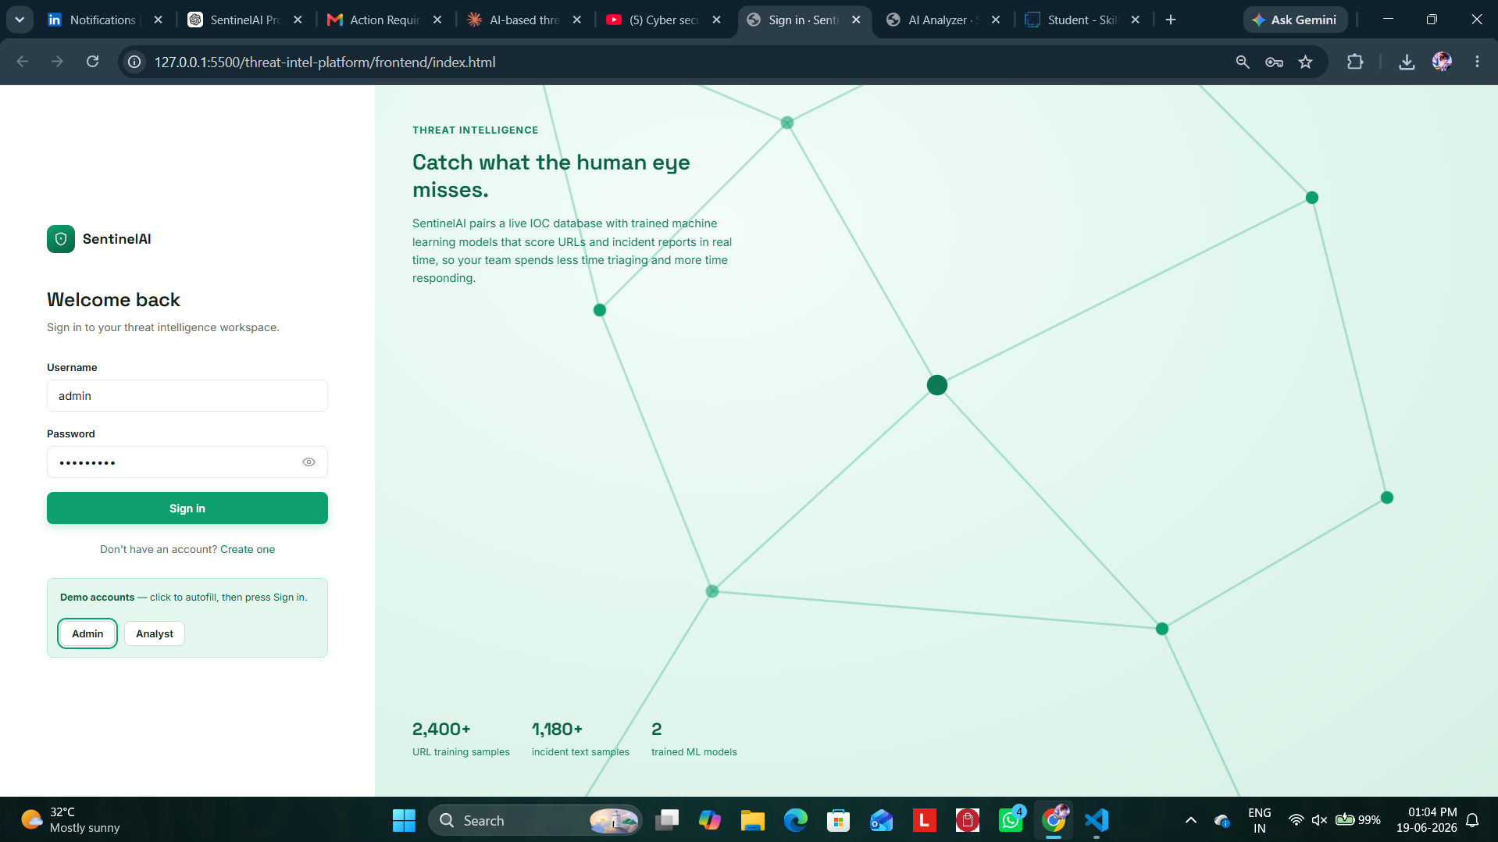

Screenshot 2: Dashboard Overview
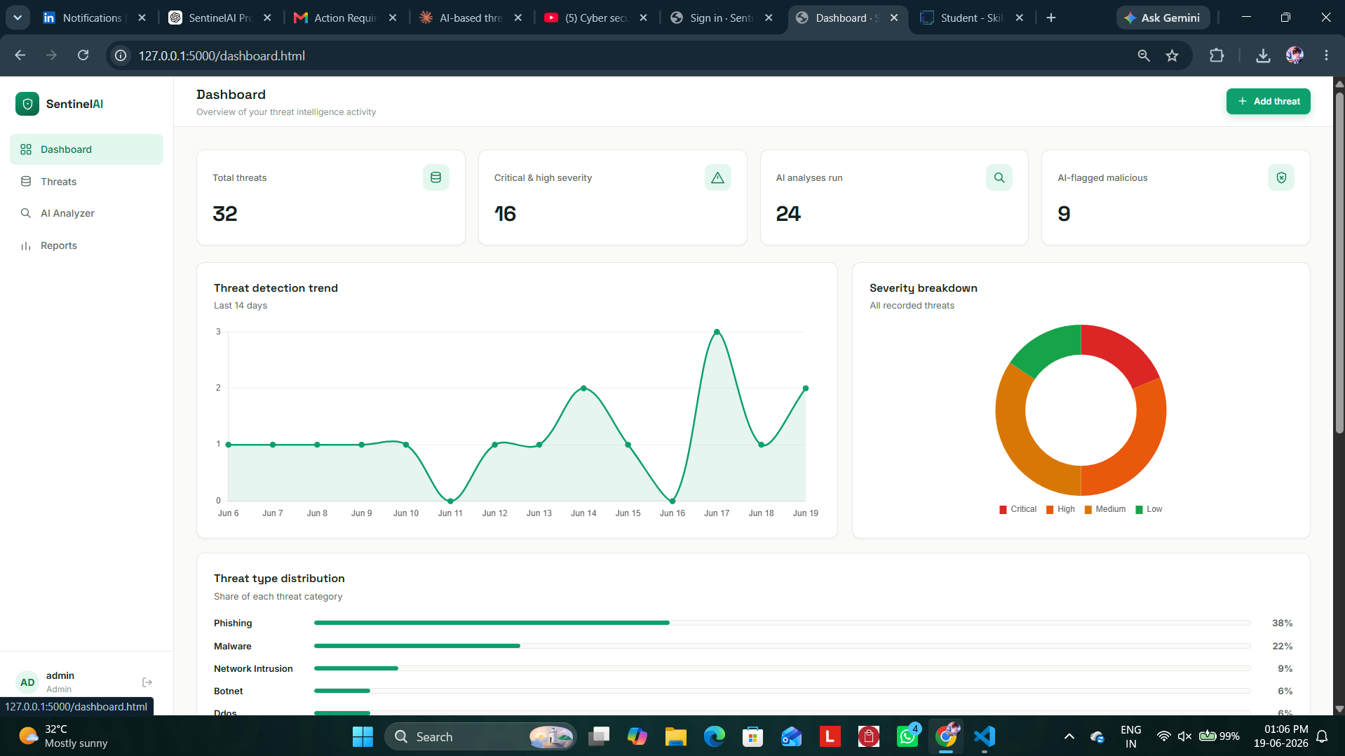

5. Installation and Execution Steps
To run the project locally, follow these steps from inside the threat-intel-platform/backend folder:
- Open the project folder and navigate into: threat-intel-platform/backend
- (Recommended) Create a virtual environment: python3 -m venv venv
- Activate it — macOS/Linux: source venv/bin/activate, Windows PowerShell: venv\Scripts\Activate.ps1
- Install dependencies: pip install -r requirements.txt (installs Flask, scikit-learn, numpy, and joblib)
- Run the application: python app.py
- Open a browser at: http://localhost:5000

On the very first run, the app automatically creates the SQLite database and tables, seeds a default admin and analyst account along with ~30 sample threat records, and trains both AI models if their .pkl files are not already present (they ship pre-trained in the project).
Role | Username | Password
Admin | admin | Admin@123
Analyst | analyst | Analyst@123

New accounts can also be created from the Register page; they default to the analyst role. To start completely fresh, stop the server and delete backend/database/threat_intel.db and the .pkl files under backend/ai_engine/trained_models/, then run python app.py again.

6. Database Design
The application uses three core SQLite tables that match the platform's authentication, threat-tracking, and AI-logging workflow.
Table Name | Main Fields | Purpose
users | id, username, email, password_hash, role, created_at | Stores registered analyst/admin accounts with hashed passwords.
threats | id, ioc_value, ioc_type, threat_type, severity, confidence_score, status, description, source, detected_at, created_by | Stores every tracked Indicator of Compromise (IOC) and its metadata.
analysis_logs | id, input_type, input_value, prediction, confidence, risk_factors, matched_existing_threat, analyzed_by, analyzed_at | Logs the result of every AI URL/text analysis ever run on the platform.

Indexes are created on threats.severity, threats.threat_type, threats.status, threats.detected_at, and analysis_logs.analyzed_at to keep dashboard and report queries fast even as the table grows. Foreign keys link both threats.created_by and analysis_logs.analyzed_by back to users.id.
Screenshot 3: Database Tables Preview
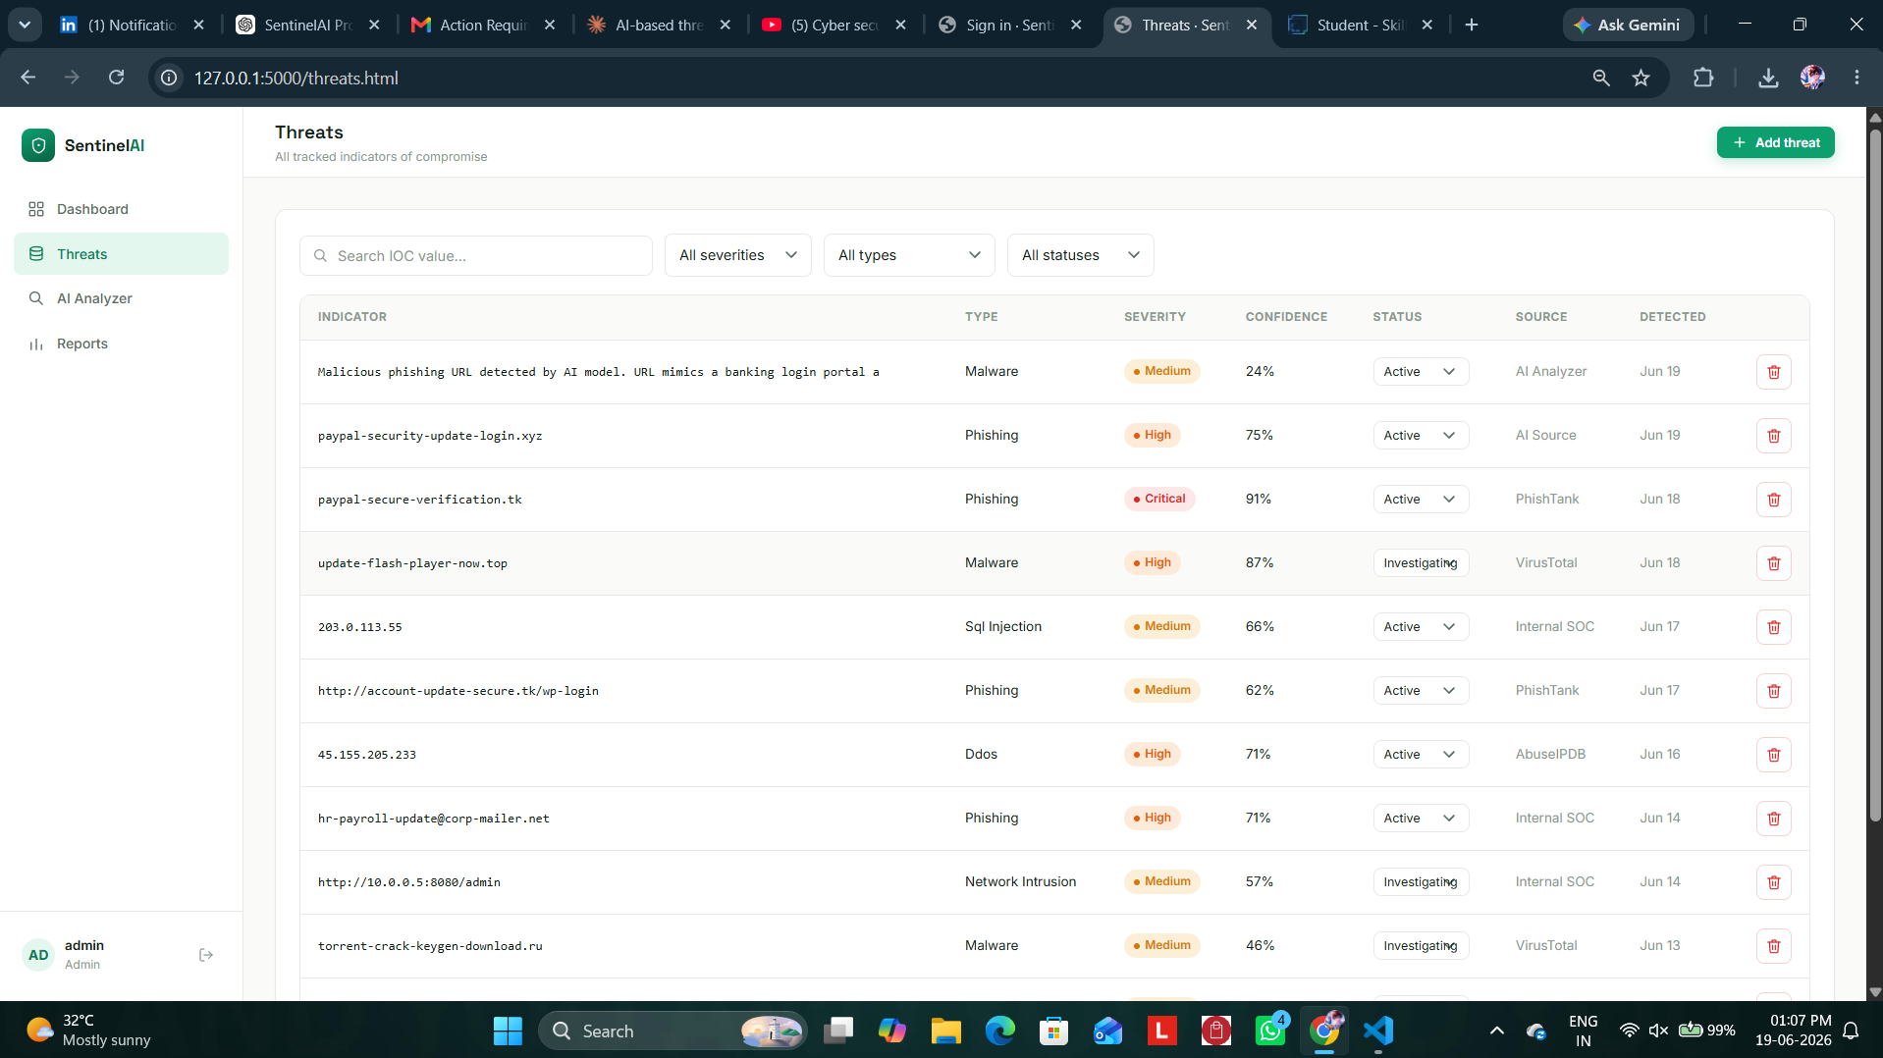

7. AI / Machine Learning Models

7.1 URL / IOC Risk Classifier
A Random Forest classifier is trained on 2,400 labeled URLs using 16 engineered lexical features — including HTTPS usage, URL entropy, presence of suspicious keywords, and whether the host is a raw IP address. Before the model is invoked, the input is first checked against the existing threats table; if it is already a known IOC, the platform reports a direct database match instead of an AI prediction. The model itself scores 100% on its held-out test split, which is an expected and explainable result for a rule-based synthetic dataset (similar in spirit to the classic UCI Phishing Websites dataset) rather than a real-world accuracy claim.

7.2 Incident Text Classifier
A TF-IDF + Logistic Regression pipeline is trained on 1,181 labeled incident descriptions spanning seven categories: phishing, malware, ransomware, DDoS, SQL injection, insider threat, and network intrusion. To keep the reported accuracy honest, the model is evaluated three different ways rather than cherry-picking one number: 5-fold cross-validation reaches roughly 99% (inflated by near-duplicate generated sentences), a held-out set written in everyday analyst phrasing reaches roughly 96% (the number shown in the app, as it best reflects real usage), and a deliberately harder symptom-only held-out set reaches roughly 66%, kept and reported as an honest stress test of the model's limits.
Model | Algorithm | Training Data | Reported Accuracy
URL Classifier | Random Forest (16 lexical features) | 2,400 labeled URLs | 100% on synthetic held-out split
Text Classifier | TF-IDF + Logistic Regression | 1,181 labeled incident descriptions | ~96% on realistic-phrasing held-out set
Screenshot 4: AI URL Analyzer Result
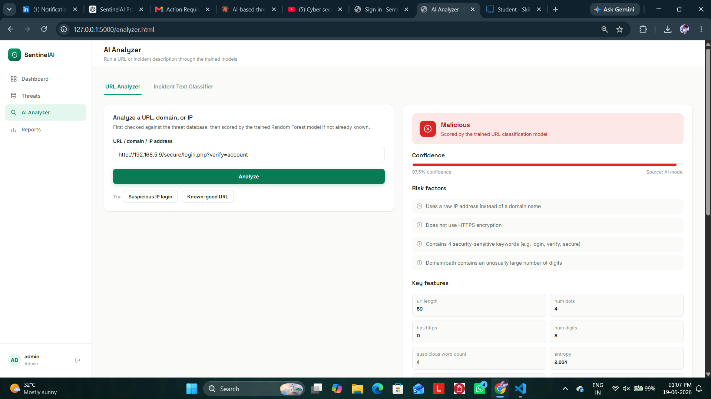

Screenshot 5: AI Incident Text Classifier Result
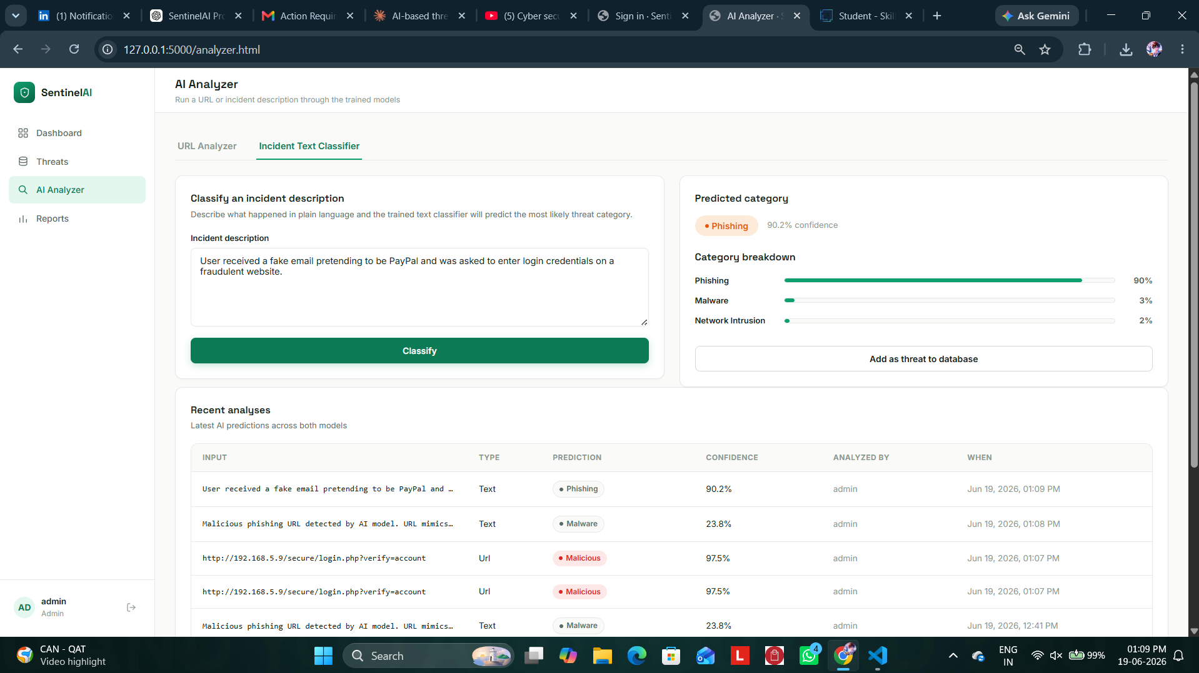

8. Application Modules with Screenshot Placeholders

8.1 Authentication (Login / Register)
Analysts log in or register with a hashed password. Sessions are signed cookies valid for 8 hours. New registrations default to the analyst role; only an admin account can delete threat records.
Screenshot 6: Registration Page
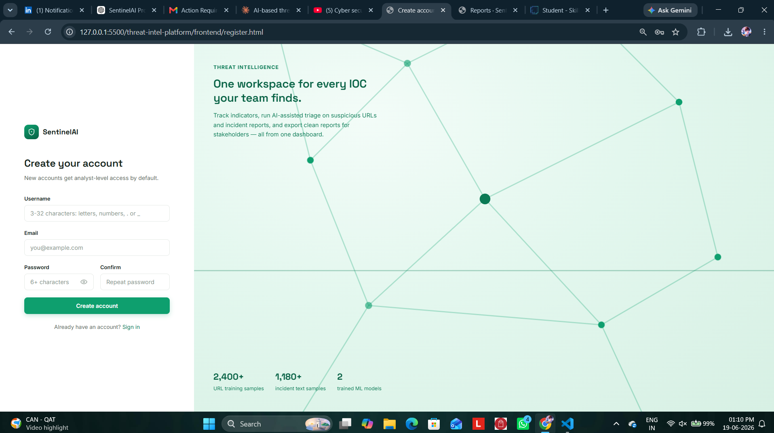

8.2 Dashboard
The dashboard shows live stat cards, a 14-day detection trend line chart, a severity breakdown donut chart, a threat-type distribution chart, and a table of the most recent threats — all populated from real database queries, not static placeholders.
Screenshot 7: Dashboard with Charts
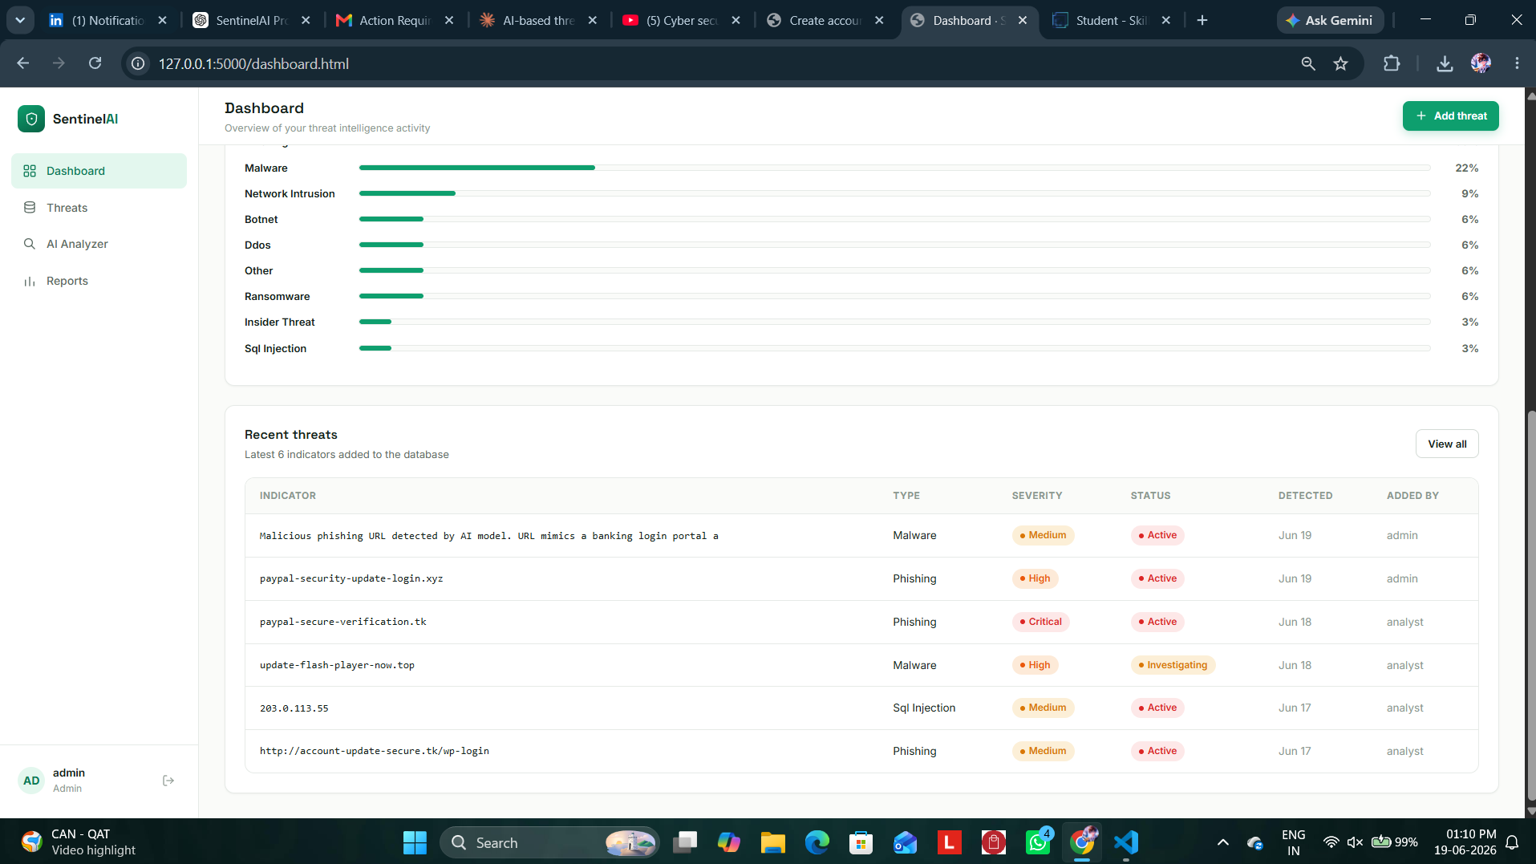

8.3 Threats Page
Analysts can search, filter (by severity, type, and status), paginate, add, update, and delete IOC records. Deleting is restricted to the admin role and is enforced both in the UI and on the backend API.
Screenshot 8: Threats List with Filters
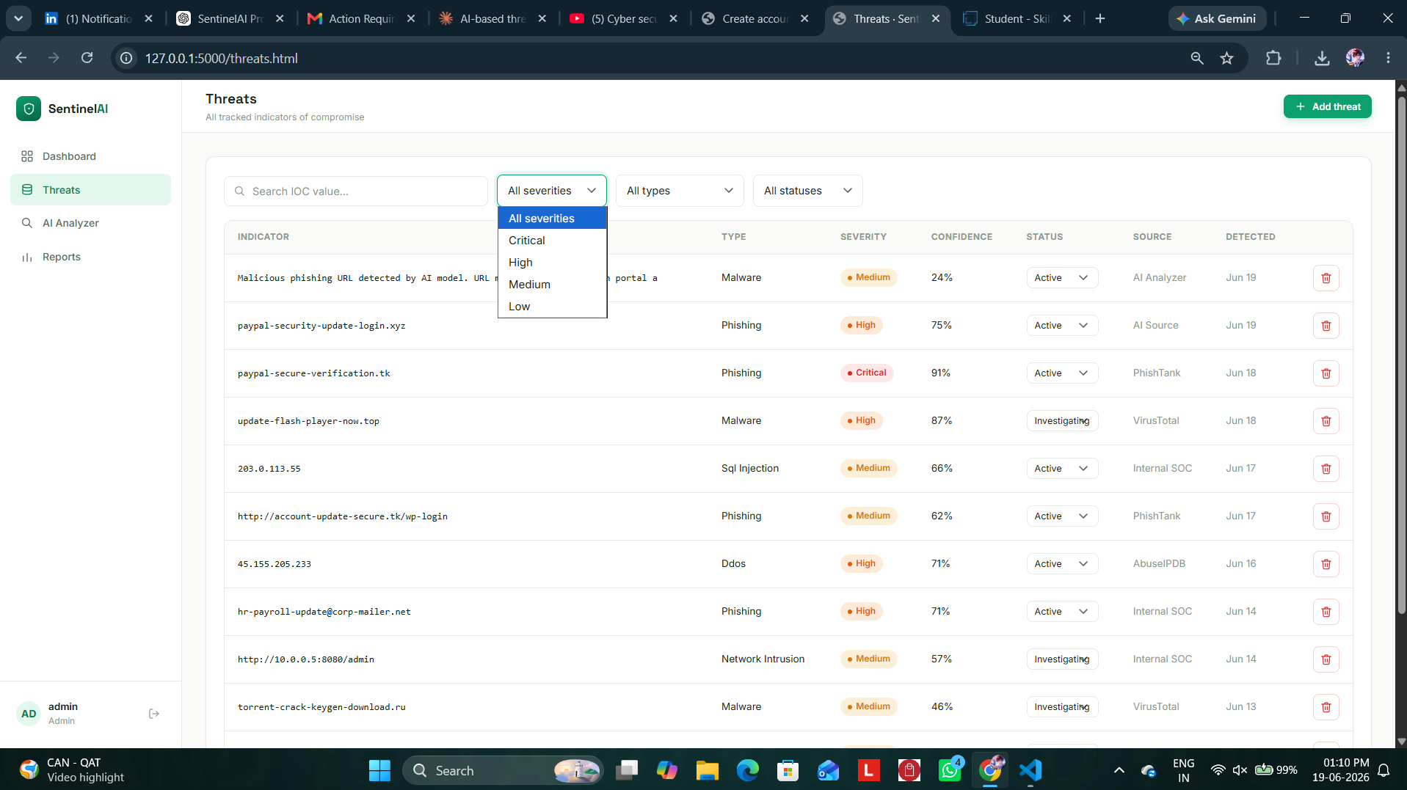

8.4 AI Analyzer
Contains two tabs: a URL Analyzer that returns a benign/suspicious/malicious verdict with plain-English risk factors, and an Incident Text Classifier that predicts the most likely attack category with a full probability breakdown.
Screenshot 9: AI Analyzer Tabs
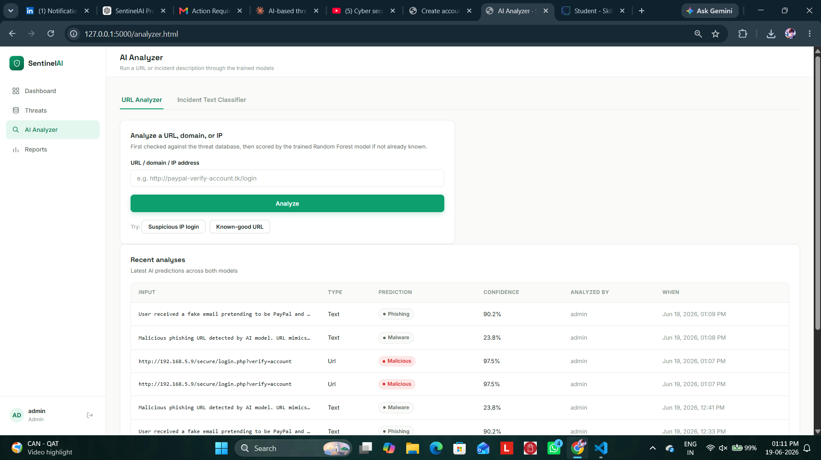

8.5 Reports
Generates date-range filtered summaries (7/30/90 days or all time) with charts and a one-click CSV export named in the form sentinelai_threat_report_30d.csv.
Screenshot 10: Reports Page with CSV Export
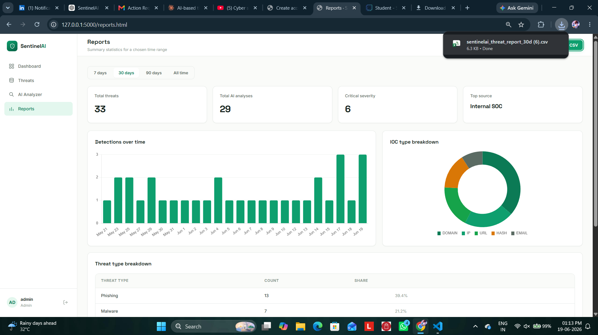

9. Testing and Verification
The platform exposes a single /api/health endpoint that reports database connectivity (user and threat counts) and whether both AI models are trained and loaded, making it the fastest way to verify the whole stack is working with one request.
Test Case | Expected Result | Status
Health check (/api/health) | Returns status: ok with database and AI model checks | Pass
User registration | New analyst account is created | Pass
Login / session protection | Visiting a protected page while logged out redirects to login | Pass
Add / search / filter threat | New IOC appears immediately and filters update the table | Pass
Admin-only delete | Delete icon hidden for analyst; API call blocked server-side for non-admins | Pass
AI URL Analyzer — known IOC | Reports a direct threat-database match instead of a model prediction | Pass
AI URL Analyzer — new URL | Returns a verdict with confidence and risk factors | Pass
AI Text Classifier | Returns predicted category with probability breakdown | Pass
Reports CSV export | Downloads a CSV matching the on-screen data | Pass

Both AI models can be re-verified live by running “python ai_engine/train_models.py” from the backend folder, which reprints the cross-validation score, the realistic held-out accuracy, and the deliberately harder held-out accuracy — useful evidence for a viva question such as “how do you know the model actually works?”

10. Limitations and Future Enhancements
- The URL classifier is trained on a synthetic, rule-based dataset; a production deployment would retrain the same pipeline on a real labeled feed such as PhishTank or OpenPhish.
- SQLite is suitable for a single-server academic deployment; a production system would migrate to a managed database such as PostgreSQL or MySQL for concurrent multi-user access.
- The text classifier's accuracy drops to roughly 66% on indirect, symptom-only incident descriptions, showing room to expand the training corpus with more naturally worded examples.
- Future enhancements could include real-time threat-feed ingestion, email/Slack alerting on critical severity detections, and deployment to a cloud platform such as AWS EC2 with a managed RDS database.

11. Conclusion
SentinelAI demonstrates a complete, working threat intelligence workflow: secure authentication, a searchable IOC database, two genuinely trained machine learning models for URL and incident triage, a live analytics dashboard, and exportable reporting — all served from a single Flask application with zero external dependencies beyond four Python packages. The project's emphasis on honestly reported AI accuracy, server-side enforcement of role-based access, and a single health-check endpoint makes it both a functional security tool and a transparent, explainable academic submission.

